**Steps To Execute our Project**

**Python Installation steps:**

We can directly click on the link below to download the setup file.

https://www.python.org/ftp/python/3.6.4/python-3.6.4-amd64.exe

Once downloaded, double-click the file to install Python 3.6 on Windows.

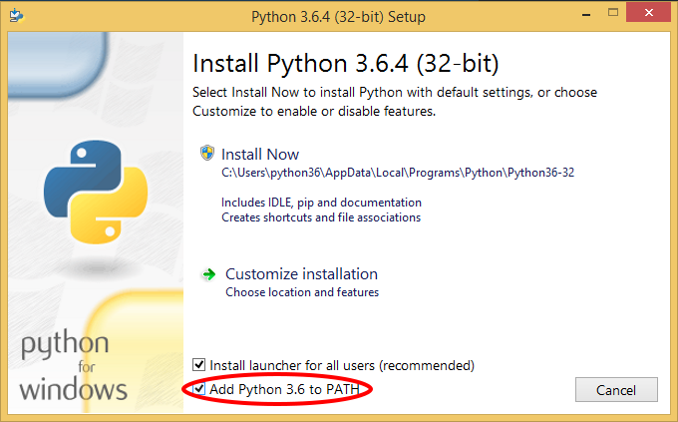

By default, the ‘Add Python 3.6 to PATH’ option is unchecked, make sure that it is checked then click on Install Now. If the setup is successful, then you should see a window as below:

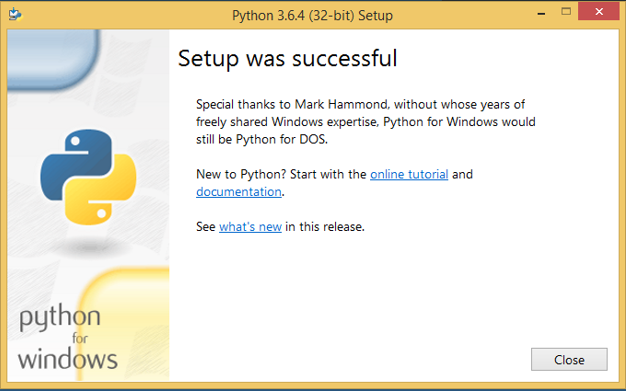

Let’s check if python 3.6 is successfully installed now. Open the command prompt and type “python” on it. If you haven’t closed the command prompt after installation, you need to close and reopen it. You will see something like:

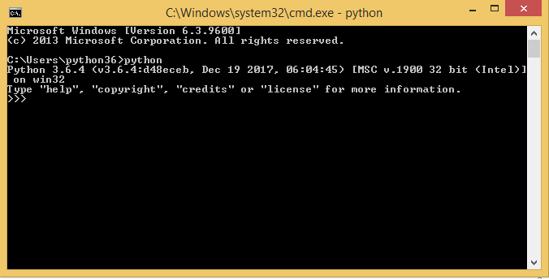

Check that the python interpreter is working properly through command prompt:

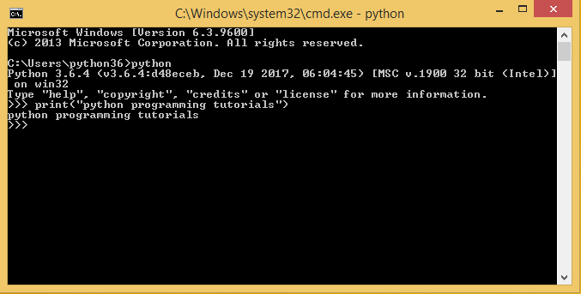

You can also search for IDLE and run python commands via. it.

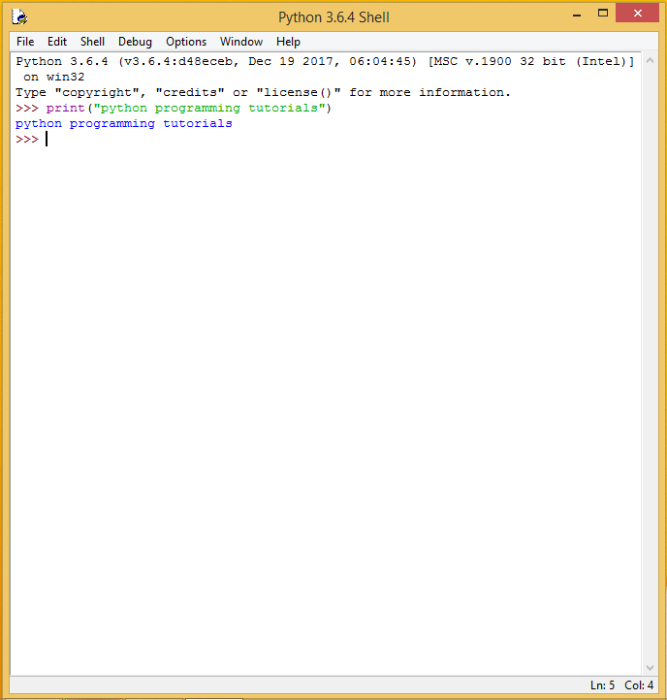

**Installation of required modules:**

* **Installation of cv2:**
  + $ pip install python-opencv
* **Installation of codecs:**
  + $ pip install python-codecs
* **Installation of PIL:**
  + $ pip install python-Pillow
* **Installation of Tkinter:**

tkinter module comes by default with python 3.x versions

well you also install alternatively:

* + $pip install python-tkinter

**Execution of source code:**

1. **Open the “main.py” file using Python IDLE:**

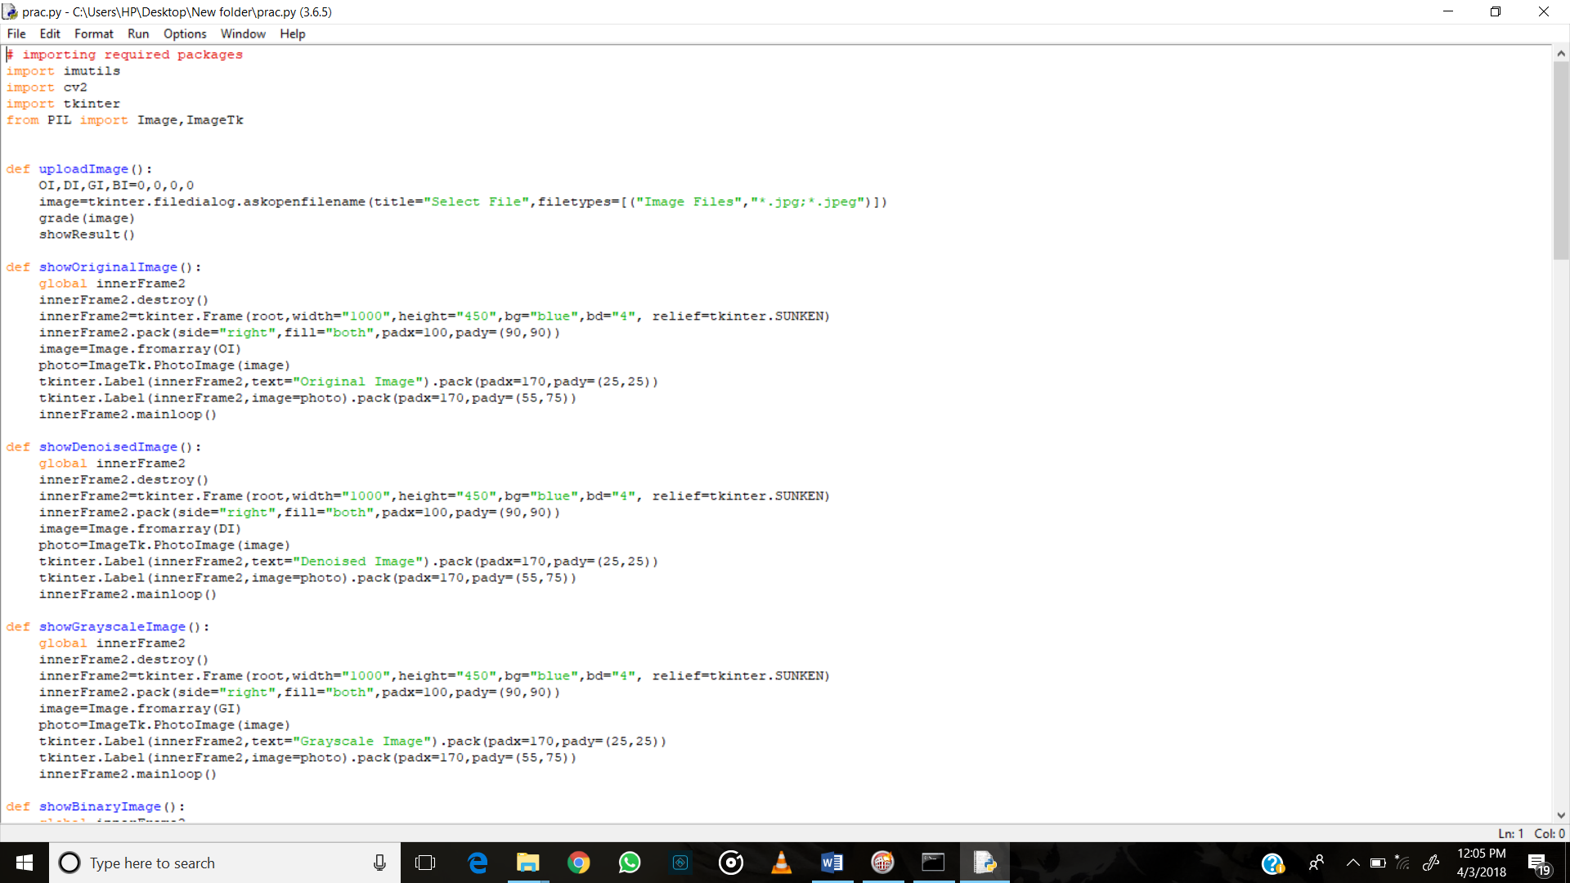

1. **On running the “main.py” file the following GUI appears:**

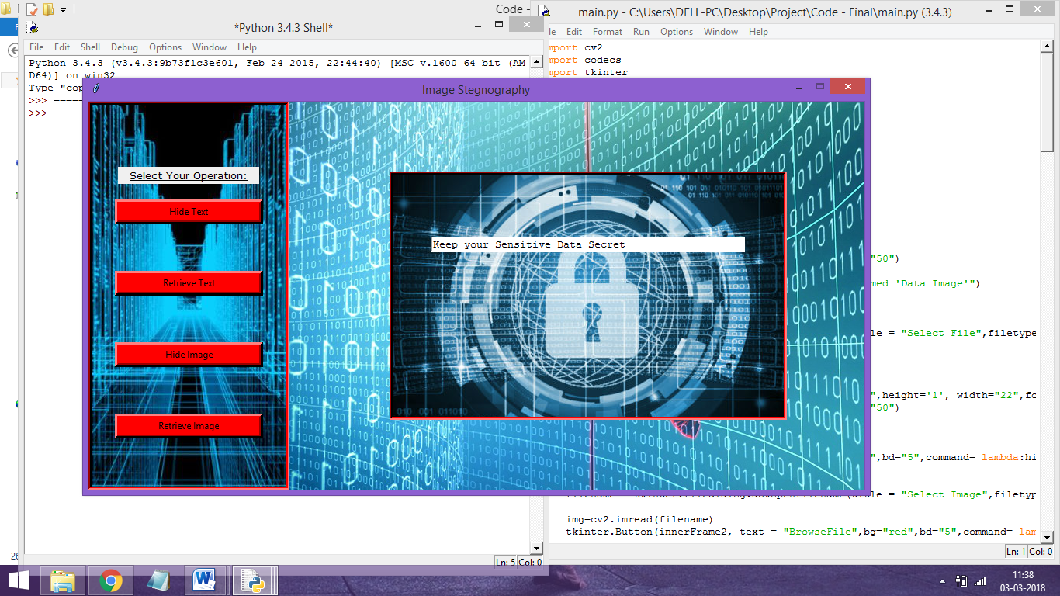

1. **Select the operation you want to perform, thereby the frame updates based on the selected operation:**

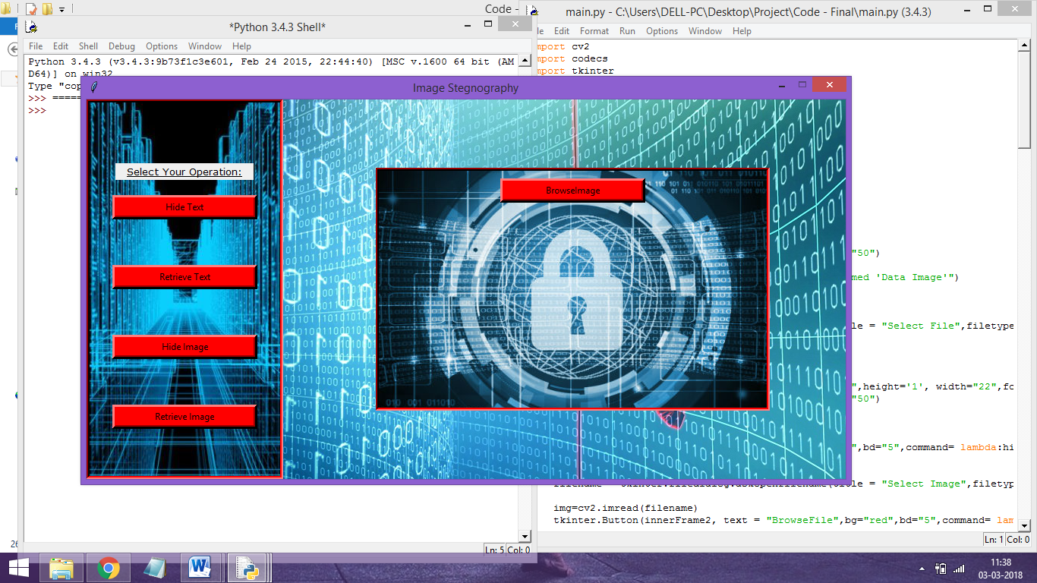

1. **Browse for the ‘image’ to hide data and the ‘data file’ or ‘secrete image’ to be hidden.**

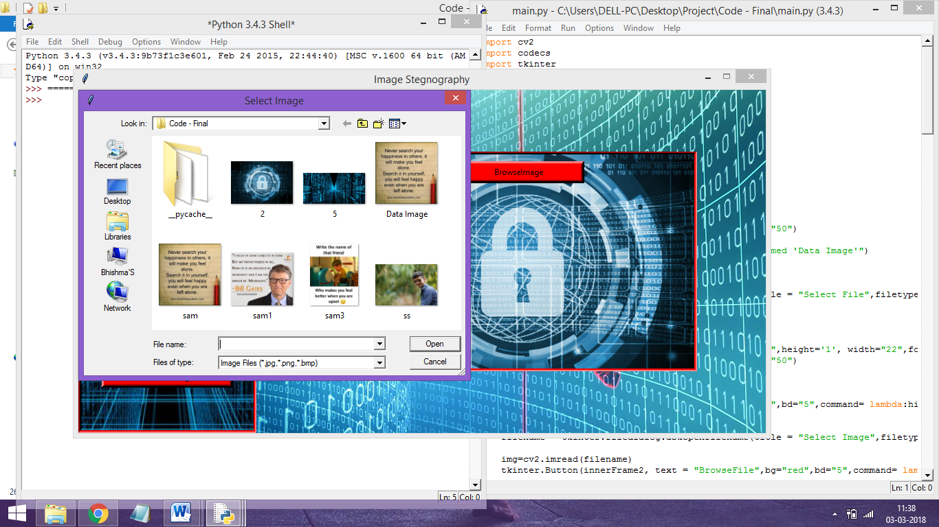

1. **Based on the selected operation, the user is asked for key to encrypt/decrypt the data.**

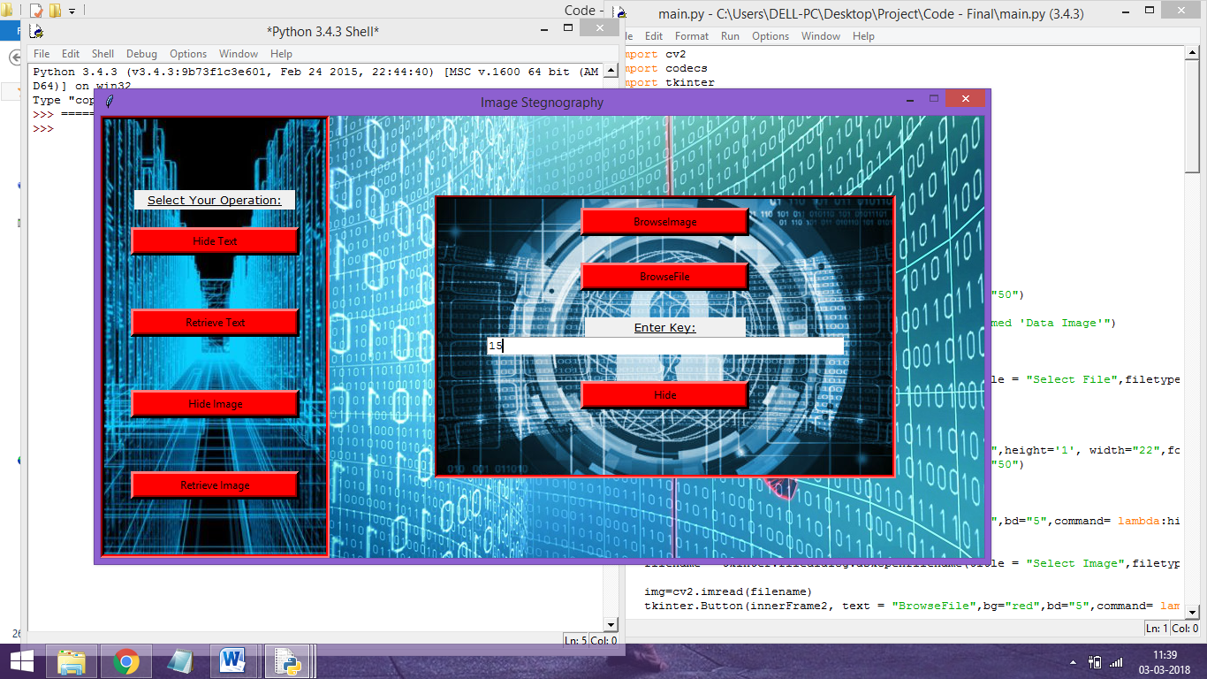

1. **Performing the selected operation the user gets message that the operation is done and the name of the image or the file where the information**

